Contact your sales rep today!
Richmond Location
#130 - 4011 Viking Way Richmond, BC, V6V 2K9 Phone: (604) 821-0075
Fax: (604) 821-0049
South Surrey Location
#140 - 19288 22 Avenue
Surrey, BC, V3Z 3S6 Phone: (604) 535-5768
Fax: (604) 542-0184
Victoria Location
2521 Government Street Victoria, BC, V8T 4P6 Phone: (250) 386-0075
Fax: (250)386-0049
www.hmebc.com

Change Tables & Nursing Benches
HME Mobility & Accessibility is a proud distributor and installer of pediatric and disability products. One of our new and exciting product lines are the change tables and nursing benches from Can-Dan Rehatec Ltd.

These products allow any public change room or washroom to accommodate both pediatric and disabled users. Traditional baby change tables only accommodate user weights up to 150 lbs, but with the products offered by HME, facilities can accommodate higher weight capacities and meet accessibility requirements.
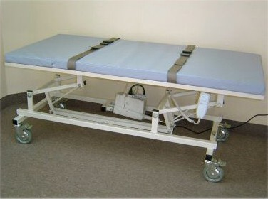
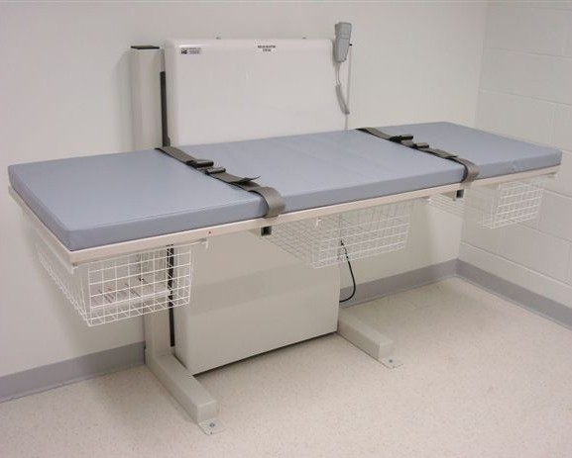

Mobile Change Table Installed Nursing Bench
Features and Benefits
*Height adjustable to allow for different client and caregiver needs
* Designed for current ergonomic and hygiene requirements while ensuring high standards of user comfort
*Durable, thoroughly tested and easy-to-clean design
*Are Health Canada certified and meet all Canadian licensing and building code requirements
*Unlike custom tables, our tables are FDA approved and certified
*Optional side-rail and shower accessories available

